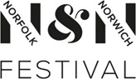**Equal Opportunities Monitoring Form**

We are committed to the equality of

opportunity in the way we choose people



for roles.

This helps make sure everyone gets treated fairly.

Your info helps us find out how we can make our selection process better.

Please fill in the form and return it to us with your application.

## We will treat it in strict confidence. It will be used only for equality monitoring.

Please answer by putting an **X** in the most

suitable box.

|  |  |
| --- | --- |
| Position applied for: |  |
| What is your UK postcode?  If you live overseas, what is the country where you live? |  |

|  |  |  |  |  |  |  |  |  |
| --- | --- | --- | --- | --- | --- | --- | --- | --- |
| Sex at birth: | Male |  | Female |  | Intersex |  | Don’t want to say |  |
| **How would you describe your gender identity?** For  example: female,  genderfluid... |  | | | | | | Don’t want to say |  |

|  |  |  |  |
| --- | --- | --- | --- |
| **How would you describe your sexuality?** Straight, pansexual…. |  | Don’t want to say |  |

**How old are you?**

**How did you hear about this opportunity?**

# **Diversity**

## Diversity questions are about your ethnic group.

|  |  |  |  |  |  |
| --- | --- | --- | --- | --- | --- |
| Choose **one option** that best describes your ethnic group or background. | | | | | |
| **Asian/Asian British** | | | | **Black/Black British** | |
| Indian | | |  | African |  |
| Pakistani | | |  | Caribbean |  |
| Bangladeshi | | |  | Any other Black / African / Caribbean background |  |
| Chinese | | |  |
| Any other Asian Background | | |  | **White** | |
| **Mixed** | | | | White British |  |
| White and Black Caribbean | | |  | White Irish |  |
| White and Asian | | |  | Gypsy, Roma or Irish Traveler |  |
| Any other Mixed / Multiple ethnic background | | |  | Any other White background |  |
| **Other** | | | |
| Arab | |  | |
| Latin American | |  | |
| Prefer not to say | |  | |
| Any other (please say) |  | | |

**Equality Act 2010**

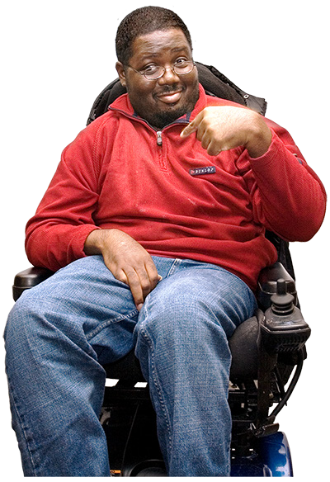

Under this law, Norfolk & Norwich Festival must:

* Stop unlawful discrimination, harassment and victimisation and other behaviour not allowed by the Act.
* Make sure there is equality of opportunity between people who share a protected characteristic and those who do not.
* Make sure there are good relations between people who share a protected characteristic and those who do not.

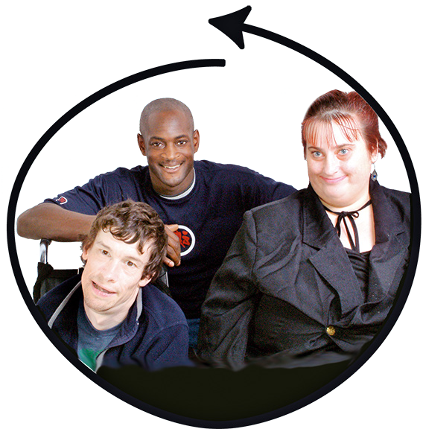These protected characteristics are:

Age, Disability, Gender reassignment, Marriage and civil partnership, Pregnancy and maternity, Race, Religion and belief, Sex, Sexual orientation.

Norfolk & Norwich Festival also sees class as an

equality characteristic.

# **Class and socio-economic background**

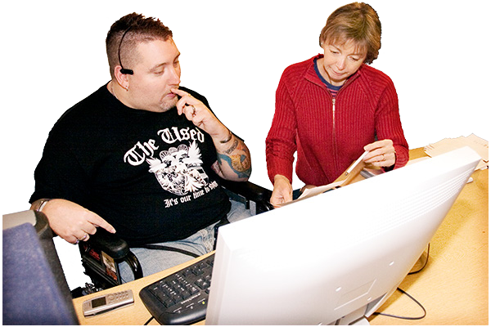This is the mix of factors that shape a person’s success in

relation to others.

This is things like: income, education, job and social

background.

|  |  |  |  |
| --- | --- | --- | --- |
| **What was the occupation of the main/highest income earner in the**  **household when you were 14?**  See how ACE define the occupations listed below: [https://www.artscouncil.org.uk/sites/default/files/download-file/](http://www.artscouncil.org.uk/sites/default/files/download-file/) Socioeconomic_occupation_definitions_0.pdf | | | |
| **Modern Professional Occupations**. e.g teacher, social worker, artist |  | **Self-employed** |  |
| **Clerical and Intermediate Occupations** e.g secretary, call centre agent, clerical worker |  | **Short Term Unemployed** Claimed jobseekers allowance or unemployment benefit for 1year or less |  |
| **Senior Managers and Administrators** e.g finance manager, chief executive |  | **Long Term Unemployed** Claimed jobseekers allowance or unemployment benefit for over 1year |  |
| **Technical and Craft**  **Occupations**  e.g motor mechanic,  plumber, train driver |  | **Retired** |  |
| **Semi-Routine Manual and**  **Service Occupations**  e.g postal worker, caretaker,  receptionist |  | **Not Applicable** |  |
| **Routine Manual and Service Occupations**  e.g HGV driver, cleaner,  labourer, waiter/waitress |  | **Don’t know** |  |
| **Middle or Junior Managers**  e.g office manager,  warehouse manager |  | **Prefer not to say** |  |
| **Traditional Professional**  **Occupations**  e.g solicitor, scientist |  | **Other - please tell us more** |  |

|  |  |  |  |
| --- | --- | --- | --- |
| **What is your current role?**  See how ACE define the occupations listed below: [https://www.artscouncil.org.uk/sites/default/files/download-file/](http://www.artscouncil.org.uk/sites/default/files/download-file/) Socioeconomic_occupation_definitions_0.pdf | | | |
| **Modern Professional Occupations**. e.g teacher, social worker, artist |  | **Self-employed** |  |
| **Clerical and Intermediate Occupations** e.g secretary, call centre agent, clerical worker |  | **Short Term Unemployed** Claimed jobseekers allowance or unemployment benefit for 1year or less |  |
| **Senior Managers and Administrators** e.g finance manager, chief executive |  | **Long Term Unemployed** Claimed jobseekers allowance or unemployment benefit for over 1year |  |
| **Technical and Craft**  **Occupations**  e.g motor mechanic,  plumber, train driver |  | **Retired** |  |
| **Semi-Routine Manual and**  **Service Occupations**  e.g postal worker, caretaker,  receptionist |  | **Not Applicable** |  |
| **Routine Manual and Service Occupations**  e.g HGV driver, cleaner,  labourer, waiter/waitress |  | **Don’t know** |  |
| **Middle or Junior Managers**  e.g office manager,  warehouse manager |  | **Prefer not to say** |  |
| **Traditional Professional**  **Occupations**  e.g solicitor, scientist |  | **Other - please tell us more** |  |

# 

# **Disability Discrimination Act 1995**

# To support applicants with disabilities, we ask them if they

have a disability and, if so, what help we can give.

|  |  |  |  |  |  |
| --- | --- | --- | --- | --- | --- |
| **Do you Identify as a deaf or disabled person, or have a long-term health**  **condition?** | | | | | |
| YES |  | NO |  | Prefer not to say |  |
| Please say how long you have had the condition, and whether you wish to tell us more about it: | | | | | |
|  | | | | | |

|  |  |  |  |  |  |
| --- | --- | --- | --- | --- | --- |
| **Do you see yourself as neuro-divergent? https://archive.acas.org.uk/neurodiversity** | | | | | |
| YES |  | NO |  | Prefer not to say |  |
| Please tell us how long you have had the condition, and whether you wish to tell us more about it: | | | | | |
|  | | | | | |

|  |
| --- |
| Tell us if there are any reasonable adjustments we may make for you to have an interview for selection:  e.g. access to venues, alternative equipment, hearing loop etc. |
|  |
| Please tell us of any reasonable adjustments we would need  to consider if you were chosen for the role. |
|  |

## Data Protection Act 1998

Your information will be processed for the purposes registered by the Employer under the Data Protection Act 1998 and the General Data Protection Regulation.