**New Volunteer Application Form 2025**

**The Festival will take place from the 9-25th May 2025**

**This application form is to volunteer at Norfolk & Norwich Festival – you will be paired with an experienced volunteer who will be your Buddy**

|  |  |
| --- | --- |
|  | **Your First name** |
| **Me man4** | **Your Last name** |
|  | **Your Address** |
| **Birth Date** | **Your Date of Birth** |
| Phone Number Home | **Your Telephone Numbers**  **Home**  **Mobile** |
| Email | **Your Email Address** |
|   **XS S**  **M L**  **XL XXL** | **Your T-Shirt Size** |

**Photography Consent**

Do you consent to having your photograph taken and used in our marketing materials including: our social media platforms, website, brochures, news articles (internally and externally) and recruitment materials? Please circle your answer.

**Yes**  **No**

**Why do you want to volunteer?** (Please circle your top 3.)

To gain experience

To build confidence

It’s Fun!



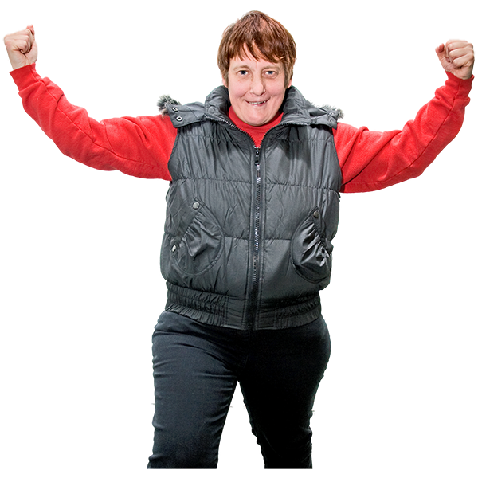

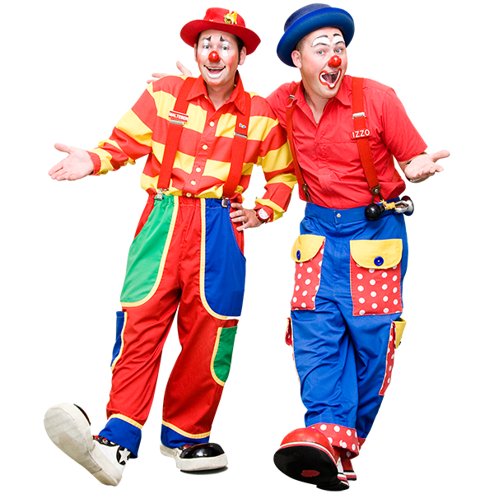

To meet people

To try something new

To help others

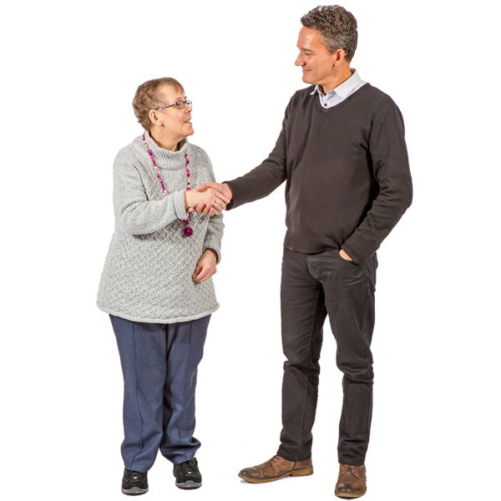



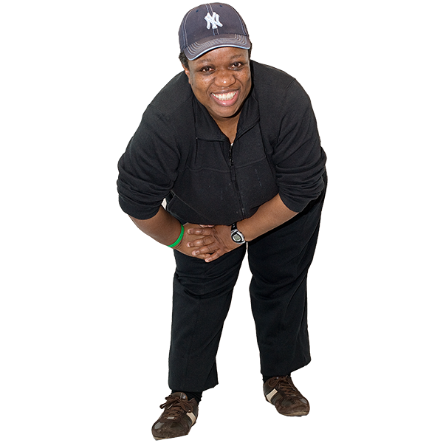

Participate in the Arts

To learn new skills

To make others happy

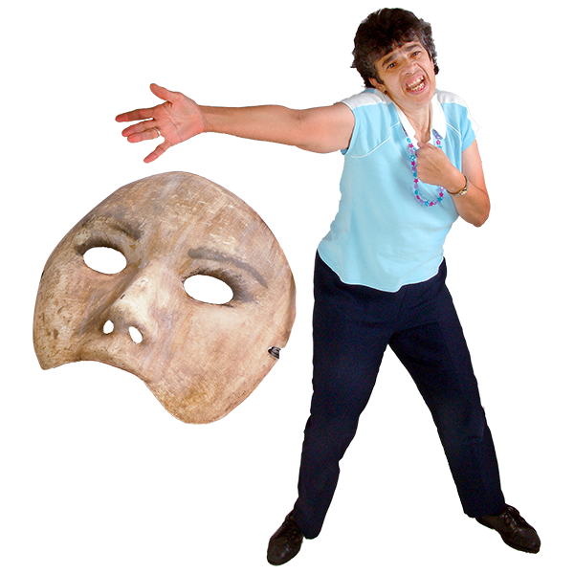





**Please use this space to add any other reasons you want to volunteer:**

|  |  |
| --- | --- |
|  | **What are your hobbies?**  **For example:**  **Do you like music?**  **Do you like football?**  **Do you like films?** |

**Buddy Scheme**

**We will match you with another volunteer who will be your buddy.**

|  |  |
| --- | --- |
|  | **Do you have any preferences about the person you are matched with?** (Age, gender, interests) |

**Support that I need**

|  |  |
| --- | --- |
|  | **Do you have a support worker / carer to help you?**  **Will that person being coming with you when you volunteer?** |
|  | **Do you have any specific health needs?** |

**Who can we contact in the event of an emergency?**

|  |  |
| --- | --- |
|  | **Name** |
|  | **Relationship to you** |
| Address Street | **Address** |
|  | **Telephone** |

**In accordance with the Data Protection Act 1998 and the General Data Protection Regulation (EU 2016/679) the Norfolk & Norwich Festival will save the information in this form so that we can keep in touch with you. We will keep your information safe and only authorised personnel will be able to access it.**

**Please sign your name here to submit this form:**

**Please write today’s date here:**

