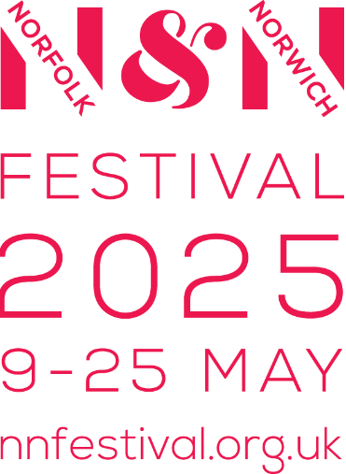
Welcome Weekend Access information
Saturday 10 and Sunday 11 May 2025
Here’s what to expect from the shows across the Welcome Weekend including information on seating and additional access provision.
Most of the shows across the weekend are brand new and have never been performed before, so some information may change.
If you have any questions about performances or access please do get in touch, on access@nnfestival.org.uk or 01603 531800 or ask volunteers or staff during the weekend.

The Forum, Theatre Plain
What 3 Words - random.short.flip
Artist - Artizani
Show name - Hydropunk
Saturday, 1-6pm
Sunday, 11.30am-4.30pm
Running Time – Ongoing, drop in and play
What to expect - Interactive water sculptures which you can come and explore.
Seating – No seating at this location

The Forum, Amphitheatre
What 3 Words - spice.donor.soap
Artist - Sadiq Ali Company
Show name - Tell Me
Saturday 1-1.45pm & 4.30-5.15pm
Sunday 11.30am-12.15pm & 2.15-3pm
Running Time – 45 minutes
What to expect - Chinese pole acrobatics, physical theatre and music. Suitable for people who are D/deaf or hard of hearing.
Seating - On The Forum steps. Accessible viewing area available outside Marzano.

Artist - Jerry Tremblay
Saturday 2.15-2.45pm, 4-4.30pm
Running Time – 30 minutes
What to expect – A one man absurd circus show, with some audience participation.
Seating - On The Forum steps. Accessible viewing area available outside Marzano..

Artist - Stopgap Dance
Show name - RO-TES - រទេះ
Sunday 12.45-1.15pm & 3.30-4pm

Running Time – 30 minutes
Touch Tour 12.15 & 3pm, 30 mins

What to expect - Dance performance
Audio Description integrated into the soundtrack
Seating - On The Forum steps. Accessible viewing area available outside Marzano.

Haymarket
What 3 Words - supply.vote.glad
Artist - Company DHW
Show name - Go Grandad Go!
Saturday 1-1.30pm, 3-3.30pm & 5-5.30pm
Running Time – 30 minutes
Touch Tour 2.45pm, 15 mins

What to expect - A Hip hop dance show with integrated visual vernacular artist in performance team.
(Visual vernacular is a form of artistic BSL interpretation developed by the BSL community).
Seating – There are benches on Haymarket.

Artist - ICHI
Sunday 1-1.45pm & 3.15-4pm
Running Time – 45 minutes
What to expect - A one-man band with homemade instruments.
Seating – There are benches on Haymarket.

Artist - Red Herring
Show name - Silent Disco
Sunday 11.45am-12.45pm & 2-3pm
Running Time – 1 hour
What to expect - Audiences wear headphones. A silent disco with a twist, lots of audience participation.
Seating - No seating as you’ll be dancing!

Norwich Cathedral, Upper Close Green
What 3 Words - pints.many.doors
Artist - Levantes Dance Theatre
Show name - Hug
Saturday 1-1.30pm & 2.45-3.15pm
Running Time – 30 minutes
What to expect - An aerial dance and physical theatre show.
Seating – Backless bench seating. There will be an accessible viewing area available.

Artist - ICHI
Saturday 1.45-2.30pm & 4-4.45pm
Running Time – 45 minutes
What to expect - A one-man band with homemade instruments.
Seating – Backless bench seating.

Artist - Red Herring
Show name - Silent Disco
Saturday 2.30-3.30pm & 5-6pm
Running Time – 30 minutes
What to expect - Audiences wear headphones. A silent disco with a twist, lots of audience participation.
Seating - No seating as you’ll be dancing!

Norwich Cathedral, Lower Close Green
What 3 Words - reward.putty.fault
Artist - Tilly Ingram Theatre
Show name - The Hide
Saturday 1.45-2.15pm & 4-4.30pm
Sunday 12-12.30pm & 1.45-2.15pm
Running Time – 30 minutes
What to expect - Audiences wear headphones to experience this meditative birdwatching experience.
Seating – Backless bench seating and chairs.

Tombland, by Ziziz
What 3 Words - rugs.stored.third
Artist - Mish Weaver
Show name - Waiting Song
Saturday 1.30-1.45pm, 3.45-4pm, 5-5.15pm
Touch Tour 3.30pm, 15 minutes
Sunday 11.30-11.45am, 1.15-1.30pm & 2.30-2.45pm
Touch Tour 2pm, 15 minutes
Running Time – 15 minutes
What to expect - Singing trapeze with optional audience participation.
Seating – Backless bench seating.

Chapelfield Gardens
What 3 Words - rating.truck.bowls
Artist - Nandita Shankardass
Show name - Roots to Rise
Saturday 2.30-3.10pm, 5-5.40pm
Touch Tour 4.45pm, 15 mins
Running Time – 40 minutes
What to expect - A dance-theatre performance which moves around Chapelfield Gardens with the audience following.
5 Audio Description headsets are available.
Seating - No seating as it’s a moving performance, there are some benches in the park if you wanted a quick rest.

Motorcycle Park above Norwich Market
What 3 Words - nearly.chained.tasty
Artist - Theatre-Rites & Miguel Altunaga
Show name - Eshu at the Crossroads
Saturday 1.45-2.15pm, 3.30-4pm & 5.15-5.45pm
Sunday 12.15-12.45pm, 1.45-2.15pm & 4-4.30pm
Running Time – 30 minutes
What to expect - Dance and puppeteering.
Seating – Backless bench seating.

Norwich Guildhall
What 3 Words - wires.deals.fight
Artist - Ian Douglas – Storyteller
Saturday 1-3pm, 3.45-5.30pm
Sunday 11.30am-1.30pm, 2.10-4.10pm
Running Time – 15 minute story sessions every 20 minutes.
What to expect - Spoken Folk Tales and world myths. Suitable for those who are blind or partially sighted.
Seating – Chairs available.

