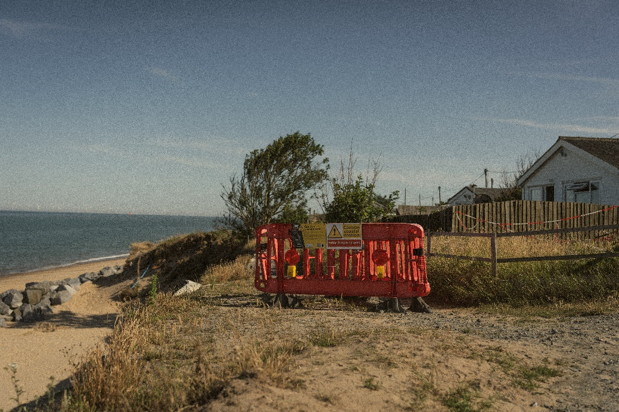
Photo credit: Joseph Harrington

From the Dunes – Creative-Writing Workshops
Free Opportunity for Schools

We would like to offer your school the opportunity to take part in From the Dunes: a free creative writing workshop for students from Key Stage 3 and above as part of Norfolk & Norwich Festival’s Connect & Create programme.

Norfolk & Norwich Festival
Festival Connect & Create
Norfolk & Norwich Festival shares exceptional arts experiences across East Anglia. We lead and support celebration, creativity and curiosity in our community to make our part of the world a great place to live, learn, work and play.

Festival Connect & Create (FC&C) is a Norfolk & Norwich Festival initiative to improve the creative and cultural lives of children and young people and their communities in East Anglia (Norfolk, Suffolk, Cambridgeshire and Peterborough). FC&C activates creative people and cultural communities by connecting leaders, delivering interventions and sharing ideas, knowledge and experiences.

We believe in the value of creative and cultural participation to develop creative potential and support social, emotional and economic wellbeing. FC&C is instrumental in Norfolk & Norwich Festival’s partnership working to support creativity in communities in places of need.

About ‘From the Dunes’
‘From the Dunes’ is a short film produced by Norfolk-based filmmaker Joe Harrington and commissioned by Norfolk & Norwich Festival, which tells the story of a family from Hemsby whose home is under direct and imminent threat from coastal erosion. Told through the eyes of two teenage boys, it is a hopeful and optimistic exploration of their personal relationship with the place they call home, and aims to give voice to a community that feel forgotten and abandoned.

The boys worked with local poet Poppy Stevens to write and perform a poem which narrates the piece, and we would love to offer your students the opportunity to reflect on the themes of home, belonging and place through creative writing.

About the Workshops
This is a writing workshop with a difference, as no previous writing experience is needed. Students will watch From The Dunes as a prompt, before taking part in fun writing games and guided exercises all designed to help them express their ideas with confidence. This workshop aims to take the fear out of writing and instead, celebrate imagination, creativity, and storytelling.

At the end of each 2-hour workshop, every student will leave with an original piece of writing, with selected work being showcased as part of Norfolk & Norwich Festival 2026.

Through our support of this film, and accompanying creative-writing workshops, we aim to give voice to, and showcase, the rich and diverse experiences of young people living in our coastal communities today.

If you are interested in taking part or have any questions about this exciting opportunity, please contact:

David Stothard – Festival Connect & Create Senior Manager david.stothard@nnfestival.org.uk

Find out more information about our Festival Connect & Create programme here.

About Poppy Stevens
Poppy Stevens is a community arts practitioner, poet and performer. Her writing has been commissioned and published by The National Centre for Writing, The Young Norfolk Arts Trust, TOAST Poetry, BBC Radio Norfolk & Suffolk, and Atrium Poetry. Poppy works within the community delivering creative workshops to a diverse range of people. Her work with children and young people spans from EYFS to Key Stage 4, both in schools, alternative provisions, and community settings. Poppy runs a regular dyslexia inclusive writing club.

As someone with dyslexia, Poppy is passionate about creating inclusive, non-judgemental spaces where neurodivergent young people can explore and enjoy creative expression on their own terms.

About JH Film Production
Joe Harringoton is a Norwich-based videographer specializing in environmental, tourism and charity films, full of heart: Videography Norwich | JH Film Production

