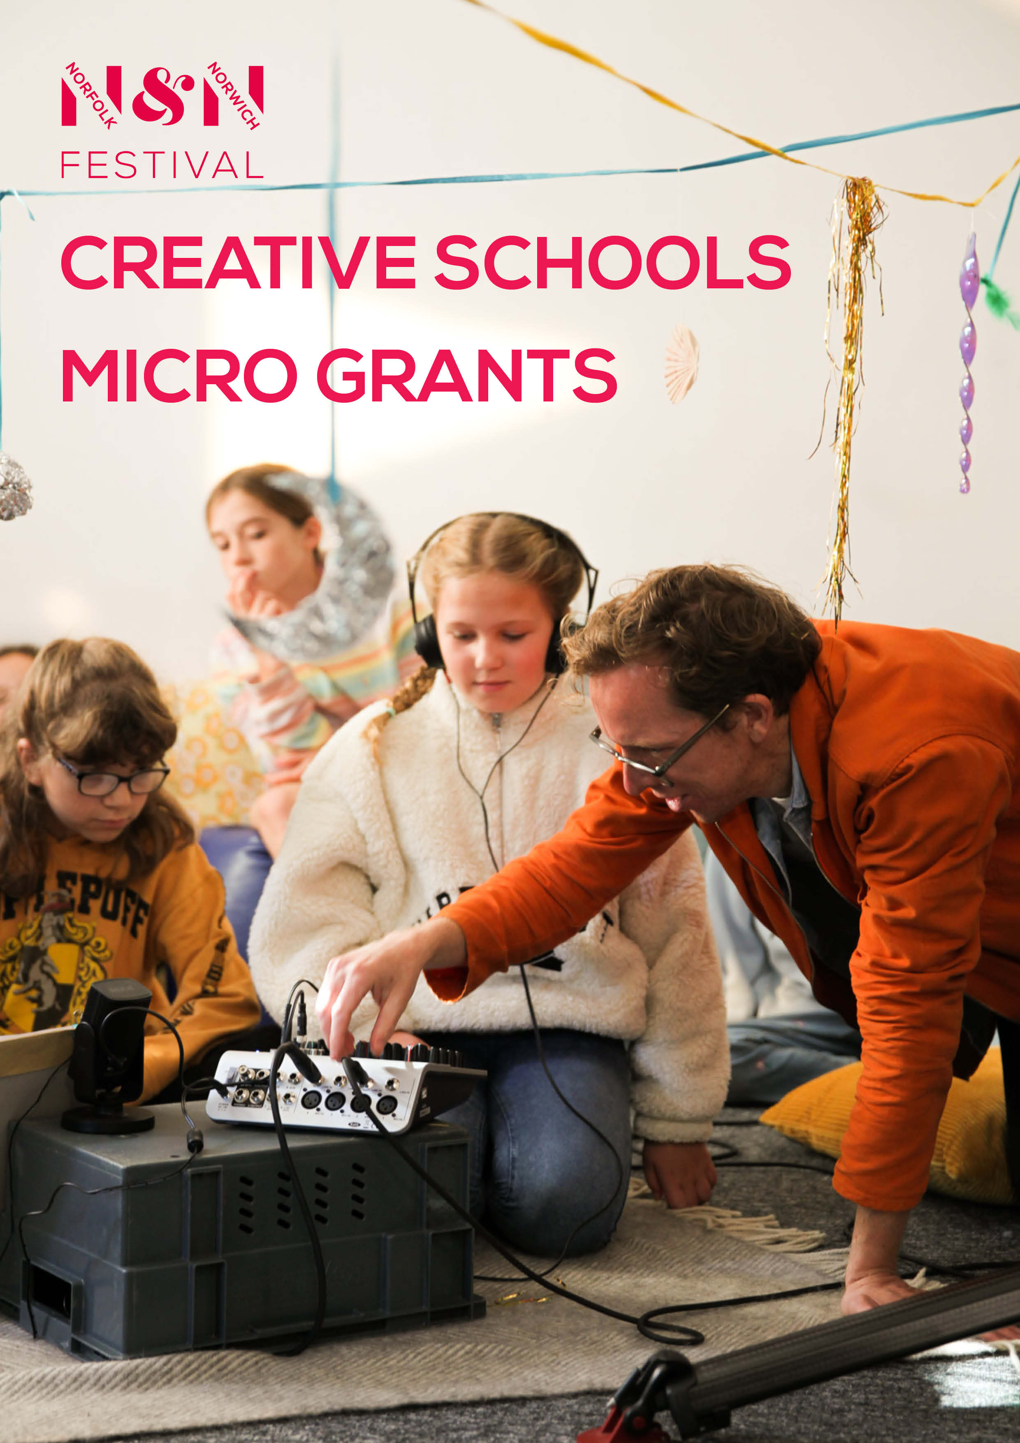

Creative Schools Micro Grants

Norfolk & Norwich Festival

Festival Connect & Create
Festival Connect & Create is a Norfolk & Norwich Festival initiative designed to foster a vibrant, socially engaged artistic economy across East Anglia – Norfolk, Suffolk, Cambridgeshire and Peterborough. At the heart of our work is the belief that every artist, child, young person and community, regardless of circumstance, should have opportunities to participate in and co-create exceptional artistic experiences. Through this work, we aim to help make East Anglia a great place to live, work and play.

Our mission is to co-create and enable collaborations and creative experiences in places of need for children, young people and their communities. We achieve this by activating artists, creative leaders and educators; strengthening cultural networks; devising meaningful creative activities; and sharing learning and best practice.

Creative Schools is a key strand of Festival Connect & Create, working in partnership with artists and educators to shape and deliver high-quality creative programmes that nurture creativity, build confidence and support the wellbeing of children and young people. The strand also creates opportunities for schools and artists to develop new partnerships, approaches and practice.

Creative Schools Micro Grants
The Festival Connect & Create team are delighted to announce the launch of our Creative Schools Micro Grants initiative – a series of seed funding grants for schools and educational settings in Norfolk, Suffolk, Cambridgeshire and Peterborough. The grants are designed to empower schools to develop creative partnerships with professional artists, build creative skills and confidence, spark new ideas for arts activity, and embed opportunities for creativity within their settings.

£500 grants are available to state-funded schools and local authority-funded SEND settings working with children and young people across all educational key stages. Funding is intended to support artist-led practical arts activities delivered within these settings. This may involve building on existing creative practice or providing opportunities to explore new techniques, approaches or art forms.

The fund may also be used to cover reasonable project materials where these are required to support the activity; however, materials cannot be the sole purpose of the funding, and grants must primarily support the delivery of creative activity by an artist.

The grants can be utilised to establish a new partnership or strengthen an existing collaboration with an artist based in Norfolk, Suffolk, Cambridgeshire or Peterborough, working in any art form.

Activity can involve direct work with children and young people, either through whole-class activity or targeted group work, or artist-led practical CPD sessions for teaching and support staff. There are no prescribed participant numbers, allowing schools and settings the flexibility to design activity that best meets their needs, priorities and ambitions.

Through this initiative, we aim to support the development of lasting relationships between schools and artists, while strengthening creative networks, collaboration and connectivity across the East Anglia region.

Please complete this short application form to apply for this exciting funding opportunity. Applications must be submitted directly by a school or educational setting, although they can be developed in partnership with the proposed artist.

Please note: all applications must have the support of the Headteacher or a named member of the Senior Leadership Team (SLT).

The deadline for applications is Monday 2 November 2026. Successful applicants will be notified on Monday 16 November 2026.

When you have completed the application form, please send a copy to fcc@nnfestival.org.uk with the subject line ‘Micro Grants’.

If you have any questions about the Micro Grants initiative or the application process then please contact: fcc@nnfestival.org.uk

(Application on next page)

Micro Grants Application Form

Name of applicant:
Job role:
Email address:

Name of school/education setting:
Website:
Name of headteacher / member of SLT:
Email address:

Name of proposed partner artist:
Is this a new or existing relationship? New / Existing
Short artist biography (maximum 150 words):
Please provide a short biography of the artist, including details of their artform, creative practice, and experience of working with children and young people, either within your setting or elsewhere. Where available, please include links to examples of previous work, a website, or an online portfolio.

Brief description of the proposed activity (maximum 250 words):
Please provide information about what activities will take place and how this grant will support your curriculum, or help meet priorities for children and young people, staff development, or your wider school improvement goals.

Please provide an indicative timeline for the proposed activity:
Exact dates are not required, but please note that all funded activity must take place between January and July 2027.

Disclaimer: Schools/educational settings and artists are responsible for ensuring that all relevant health and safety and safeguarding requirements are met in line with the policies and procedures of the school or setting. This includes ensuring that any artist delivering activity holds an appropriate DBS certificate and valid Public Liability Insurance (PLI) where needed.

By ticking this box, you confirm that, if your application is successful, you will complete a short evaluation survey at the end of your funded activity

By ticking this box, you confirm that, if your application is successful, you will take part in a short online celebration event in July 2027

Please tick this box if you would like to sign up for the Festival Connect & Create newsletter

Signed (teacher):
Date:

Signed (headteacher/member of SLT):
Date:

Send completed application to fcc@nnfestival.org.uk

Your Questions Answered

Who can apply?
Applications must be submitted by a state-funded school or Local Authority-funded SEND setting based in Norfolk, Suffolk, Cambridgeshire or Peterborough. Applications cannot be submitted by artists on behalf of a school, although they can be developed collaboratively.

The fund is open to:
- Primary schools
- Secondary schools
- Special schools
- Local Authority-funded SEND settings
- Alternative provision settings (where state-funded)

If you are unsure whether your setting is eligible, please contact us before applying.

What can the funding be used for?
The grant is intended to support artist-led creative activity. This could include:

- Artist fees
- Artist travel expenses
- Materials required to deliver the activity
- Artist-led practical CPD for teaching and support staff

Projects can involve direct work with children and young people, staff training, or a combination of both.

Can the funding be used to buy equipment or materials?
Yes. The grant may be used to purchase materials or equipment where these are essential to delivering the proposed activity. However, materials or equipment cannot be the sole purpose of the funding, and the majority of the grant should support artist-led creative activity.

For example, a project budget might include £300 towards artist fees (equivalent to one full day or two half-days of delivery) and £200 for materials required to deliver the workshops. This is intended as an example only, and applicants are welcome to propose a different balance of costs where appropriate.

Do we need to have an artist already?
Yes. A proposed artist must be named in your application. If you have not yet identified an artist, please contact the Festival Connect & Create team before submitting your application. We may be able to help connect you with practitioners based in your area.
Does the artist need to live locally?
Yes. Artists should be based in Norfolk, Suffolk, Cambridgeshire or Peterborough.

Can we apply if we have never worked with an artist before?
Absolutely. The fund is designed both to support schools developing new creative partnerships and those wishing to build on existing relationships.

Which art forms are eligible?
We welcome applications involving any art form, including (but not limited to):

- Visual arts
- Theatre
- Dance
- Music
- Creative writing
- Spoken word
- Digital arts
- Film
- Photography
- Circus
- Craft
- Printmaking
- Sculpture
- Storytelling

For inspiration and examples of artist-led projects in schools, please visit the Creative Schools page on our website.

How many participants should be involved?
There is no minimum or maximum number of participants. Schools should design activity that best meets their needs. The funding can support work with a whole class, multiple classes, a targeted group of pupils, or teaching and support staff.

When must the activity take place?
Funded activity should take place between January and July 2027. Successful applicants will receive further information about the grant process and delivery requirements following notification.

As part of the funding, successful schools will be asked to complete a short evaluation survey and attend a brief online celebration event in July 2027.

Who can I contact if I have further questions?
Please email fcc@nnfestival.org.uk and a member of the Festival Connect & Create team will be happy to help.

